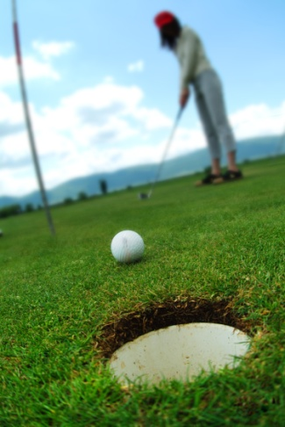

The Golf Course
By: Marshall Mennis
And Dillon DumpRoelandt
The golf carts were on the bay,
so the golf clubs wanted to play,
The golf balls were reading a book,
When the driving range was playing with a nook.
The flags were riding bike,
When the bathrooms where playing with a tike.
The grass stared dancing,
When the golf course started prancing,

